**LAPORAN PRAKTIKUM**

**MATA KULIAH PEMROGRAMAN BERBASIS FRAMEWORK**

Laporan ini dibuat untuk memenuhi tugas Mata Kuliah Program Berbasis Framework



Dosen Pengampu :  
Achmad Muzakki, S.Kom., M.Kom

Dengan Asisten Praktikum :

* A
* B

Pembuat :  
Evi Fitriya 1201222005

Rekayasa Perangkat Lunak

Fakultas Informatika

Telkom University Surabaya

2024

# DAFTAR ISI

DAFTAR ISI i

PERTEMUAN 1 MATERI FRAMEWORK 1

TUGAS : Hanya mengintsal Aplikasi aplikasi yang dibutuhkan, tidak perlu mengumpulkan apa-apa. 1

PERTEMUAN 2 Route, View, Blade Templates 2

TUGAS : Mengimplementasikan Konsep Route dan View dengan minimal 3 pemanggilan Variable dari sisi Route 4

HASIL 4

LINK TO FILE 4

KODE 5

SCREENSHOT 16

# PERTEMUAN 1 MATERI FRAMEWORK

1. Pengenalan tentang Laravel
2. Instalasi

* XAMPP 8.1.25 / PHP 8.1.25 [LINK](https://sourceforge.net/projects/xampp/files/XAMPP%20Windows/8.1.25/xampp-windows-x64-8.1.25-0-VS16-installer.exe)
* Compose latest [LINK](https://getcomposer.org/Composer-Setup.exe)
* Laravel v9 [LINK](https://laravel.com/docs/9.x/installation)
* IDE [LINK](https://code.visualstudio.com/download)

1. Basic

* Routing
* Middleware
* Controller
* View
* Model
* Request
* Responses
* CSRF
* Blade templates
* Session
* Validation
* Error Handling

1. Database

* Migration
* Seeding
* Query Builder
* Faker

1. Eloquent ORM

* Relationship
* Collection
* Serialization

1. Testing

* Browser Test
* Unit Test*

1. Front End

* HTML
* CSS
* Bootstrap

Apabila sudah instal, berikut penjelasannya :

* Resources : Untuk Html
* Routes : Untuk mengatur routing yang dipanggil dari sisi html
* Public : Untuk mengatur Css

## TUGAS : Hanya mengintsal Aplikasi aplikasi yang dibutuhkan, tidak perlu mengumpulkan apa-apa.

# **PERTEMUAN 2 Route, View, Blade Templates**

1. MVC

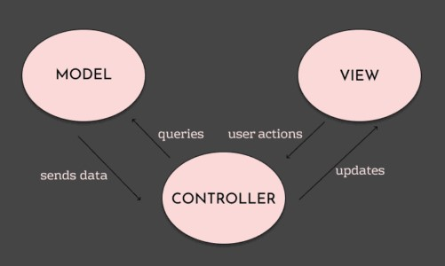

Laravel sudah menggunakan pola arsitektur MVC yang digunakan untuk memisahkan komponen utama dalam pengembangan website sehingga dapat memudahkan dalam melakukan pengujian dan pemeliharaan kode.

1. Route

Pengertian

Route atau rute merupakan suatu proses menghubungkan URL dengan fungsi atau controller. Pada route ini juga digunakan untuk menentukan cara website dalam merespons permintaan HTTP dari pengguna. ● Fungsi dan kegunaan routing

* Menetapkan URL ke dalam tindakan atau fungsi tertentu pada aplikasi
* Memberikan struktur dan organisasi pada navigasi aplikasi web.
* Mendukung penggunaan parameter untuk menangkap dan memproses data.
* Menggunakan middleware untuk memproses permintaan sebelum mencapai tindakan pengontrol.
* Menetapkan data ke dalam tindakan atau logika pengontrol (controller) yang sesuai.

Contoh penggunaan

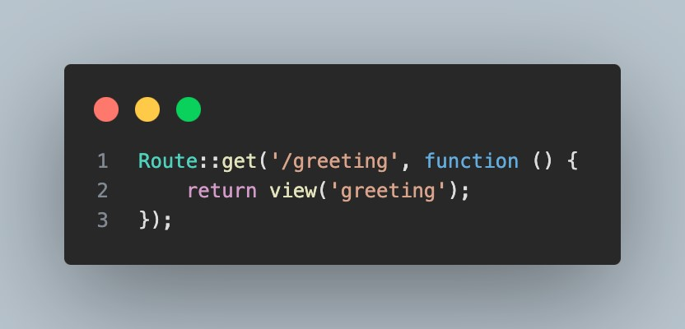

**Keterangan :**

Mengembalikan tampilan yang bernama “greeting.blade.php” pada URL example.com/greeting.

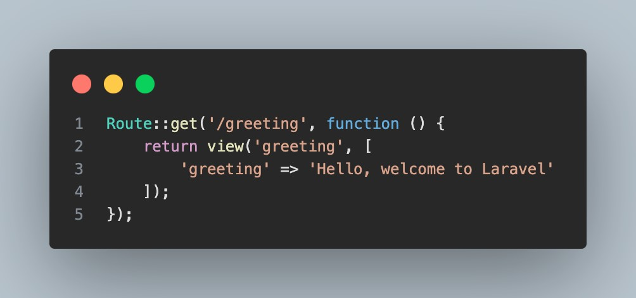

**Keterangan :**

Mengembalikan tampilan yang bernama “greeting.blade.php” pada URL example.com/greeting dengan memberikan argumen yang memiliki key “greeting” dan memiliki value “Hello, welcome to Laravel”.

1. View

Pengertian

View merupakan komponen yang bertanggung jawab dalam menangani tampilan atau antarmuka pengguna. Sehingga pada view ini merupakan file yang berisi tampilan HTML dan kode PHP yang akan ditampilkan kepada pengguna. ● Fungsi dan kegunaan view

* Memisahkan logika presentasi dari logika bisnis dalam MVC (Model-View-Controller) pattern.
* Menghasilkan HTML atau tampilan lainnya untuk ditampilkan kepada pengguna.
* Menyederhanakan proses pembuatan dan pemeliharaan antarmuka pengguna.
* Memungkinkan reusabilitas dan organisasi yang baik dari kode tampilan.

Contoh penggunaan

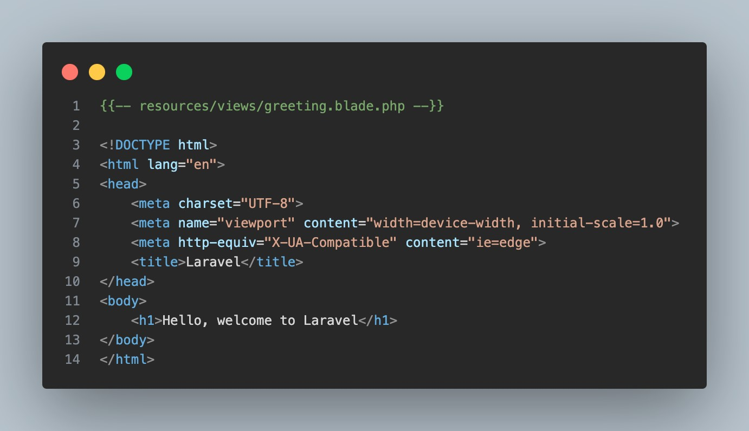

**Keterangan :**

Menampilkan “Hello, welcome to Laravel!”. Pada halaman ini juga digunakan untuk mengatur tampilan pengguna.

1. Blade Templates

Pengertian

Blade template merupakan fitur dari laravel untuk membuat tampilan yang dinamis dan mudah dibaca. Pada blade template juga menyediakan sintaks yang clean code untuk menulis kode PHP dalam tampilan.

* Fungsi dan kegunaan blade
* Memudahkan penulisan kode PHP dalam tampilan dengan sintaks yang bersih.
* Mendukung struktur kontrol seperti perulangan dan kondisional dengan sintaks yang jelas.
* Memungkinkan penggunaan template inheritance untuk organisasi tampilan hierarkis.

Contoh penggunaan

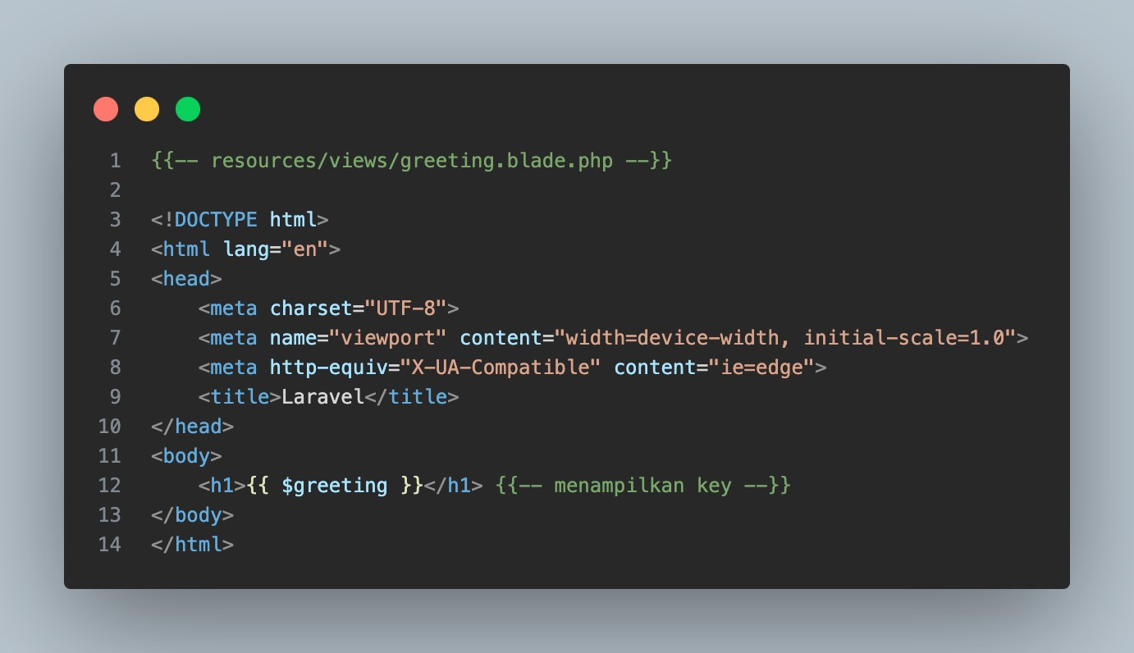

**Keterangan :**

Menampilkan value ”Hello, welcome to Laravel!” dari key “greeting” dengan menggunakan sintaks “{{ }}”.

## TUGAS : Mengimplementasikan Konsep Route dan View dengan minimal 3 pemanggilan Variable dari sisi Route

## HASIL

### LINK TO FILE

<https://telkomuniversityofficial-my.sharepoint.com/:u:/g/personal/evifitriya_student_telkomuniversity_ac_id/EV6-OcYIRZtHh255Y8HEXOcBz_HXo-o0mIJ3Bw_7Nrhi6w?e=unsfx4>

### KODE

1. HTML AS PHP
2. Navbar

<head>

    <meta charset="utf-8">

    <meta content="width=device-width, initial-scale=1.0" name="viewport">

    <title>Evi PF01</title>

    <meta content="" name="description">

    <meta content="" name="keywords">

    <!-- Favicons -->

    <link href="assets/img/marvel aset.jpg" rel="icon">

    <!-- Google Fonts -->

    <link href="https://fonts.googleapis.com/css?family=Open+Sans:300,300i,400,400i,600,600i,700,700i|Raleway:300,300i,400,400i,500,500i,600,600i,700,700i|Poppins:300,300i,400,400i,500,500i,600,600i,700,700i" rel="stylesheet">

    <!-- Vendor CSS Files -->

    <link href="assets/vendor/aos/aos.css" rel="stylesheet">

    <link href="assets/vendor/bootstrap/css/bootstrap.min.css" rel="stylesheet">

    <link href="assets/vendor/bootstrap-icons/bootstrap-icons.css" rel="stylesheet">

    <link href="assets/vendor/boxicons/css/boxicons.min.css" rel="stylesheet">

    <link href="assets/vendor/glightbox/css/glightbox.min.css" rel="stylesheet">

    <link href="assets/vendor/swiper/swiper-bundle.min.css" rel="stylesheet">

    <!-- Template Main CSS File -->

    <link href="app.css" rel="stylesheet">

    <!-- =======================================================

  * Template Name: iPortfolio

  * Updated: Jan 29 2024 with Bootstrap v5.3.2

  * Template URL: https://bootstrapmade.com/iportfolio-bootstrap-portfolio-websites-template/

  * Author: BootstrapMade.com

  * License: https://bootstrapmade.com/license/

  ======================================================== -->

</head>

<body>

    <!-- ======= Mobile nav toggle button ======= -->

    <i class="bi bi-list mobile-nav-toggle d-xl-none"></i>

    <!-- ======= Header ======= -->

    <header id="header">

        <div class="d-flex flex-column">

            <div class="profile">

                <img src="assets/img/marvel aset.jpg" alt="" class="img-fluid rounded-circle">

                <h1 class="text-light"><a href="https://github.com/conybrow">Evi Fitriya</a></h1>

                <a href="https://pddikti.kemdikbud.go.id/data_mahasiswa/MjVFM0RCQTUtMjBGNi00NjhFLUE2OTItN0I2MjA3OEQ3MzAz">(1201222005)</a>

                <h1 class="text-light" id="tugas"><a href="https://telkomuniversityofficial-my.sharepoint.com/:b:/g/personal/evifitriya_student_telkomuniversity_ac_id/ERMOJREKyjFGqCKTZFP66L8Bvysvhb9zS75f2U-mUqJeAw?e=39MUUN">Tugas Pemrograman Framework 01</a></h1>

                <div class="social-links mt-3 text-center">

                </div>

            </div>

<nav id="navbar" class="nav-menu navbar">

    <ul>

        <li><a href="{{ url('/') }}" class="nav-link scrollto active"><i class="bx bx-home"></i> <span>All</span></a></li>

        <li><a href="{{ url('/ironMan') }}" class="nav-link scrollto"><i class="bx bx-user"></i> <span>Father Iron Man</span></a></li>

        <li><a href="{{ url('/Thor') }}" class="nav-link scrollto"><i class="bx bx-file-blank"></i> <span>Second Father Thor</span></a></li>

        <li><a href="{{ url('/ds') }}" class="nav-link scrollto"><i class="bx bx-book-content"></i> <span>Uncle Doctor Strange</span></a></li>

    </ul>

</nav>

1. Halaman Utama

<!DOCTYPE html>

<html lang="en">

            <!-- navbar import disini -->

            @include('navbar')

            <!-- .nav-menu -->

        </div>

    </header>

    <!-- End Header -->

    <!-- ======= Hero Section ======= -->

    <section id="hero" class="d-flex flex-column justify-content-center align-items-center" style="background: url('{{ asset('/assets/img/'.$photo) }}') top center;">

        <div class="hero-container" data-aos="fade-in">

            <h1>{{$tokoh}}</h1>

            <p> <span class="typed" data-typed-items="{{$slogan}}"></span></p>

        </div>

    </section>

    <!-- End Hero -->

    <!-- ======= Footer ======= -->

    <footer id="footer">

        <div class="container">

            <div class="credits">

                <!-- All the links in the footer should remain intact. -->

                <!-- You can delete the links only if you purchased the pro version. -->

                <!-- Licensing information: https://bootstrapmade.com/license/ -->

                <!-- Purchase the pro version with working PHP/AJAX contact form: https://bootstrapmade.com/iportfolio-bootstrap-portfolio-websites-template/ -->

                Designed by Tony's Daughter : <a href="https://www.instagram.com/evftrya_/">Evi Fitriya</a>

            </div>

        </div>

    </footer>

    <!-- End  Footer -->

    <a href="#" class="back-to-top d-flex align-items-center justify-content-center"><i class="bi bi-arrow-up-short"></i></a>

    <!-- Vendor JS Files -->

    <script src="assets/vendor/purecounter/purecounter_vanilla.js"></script>

    <script src="assets/vendor/aos/aos.js"></script>

    <script src="assets/vendor/bootstrap/js/bootstrap.bundle.min.js"></script>

    <script src="assets/vendor/glightbox/js/glightbox.min.js"></script>

    <script src="assets/vendor/isotope-layout/isotope.pkgd.min.js"></script>

    <script src="assets/vendor/swiper/swiper-bundle.min.js"></script>

    <script src="assets/vendor/typed.js/typed.umd.js"></script>

    <script src="assets/vendor/waypoints/noframework.waypoints.js"></script>

    <script src="assets/vendor/php-email-form/validate.js"></script>

    <!-- Template Main JS File -->

    <script src="assets/js/main.js"></script>

</body>

</html>

1. Halaman Iron Man

<!DOCTYPE html>

<html lang="en">

            <!-- navbar import disini -->

            @include('navbar')

            <!-- .nav-menu -->

        </div>

    </header>

    <!-- End Header -->

    <!-- ======= Hero Section ======= -->

    <section id="hero" class="d-flex flex-column justify-content-center align-items-center" style="background: url('{{ asset('/assets/img/'.$photo) }}') top center;">

        <div class="hero-container" data-aos="fade-in">

            <h1>{{$tokoh}}</h1>

            <p> <span class="typed" data-typed-items="{{$slogan}}"></span></p>

        </div>

    </section>

    <!-- End Hero -->

    <!-- ======= Footer ======= -->

    <footer id="footer">

        <div class="container">

            <div class="credits">

                <!-- All the links in the footer should remain intact. -->

                <!-- You can delete the links only if you purchased the pro version. -->

                <!-- Licensing information: https://bootstrapmade.com/license/ -->

                <!-- Purchase the pro version with working PHP/AJAX contact form: https://bootstrapmade.com/iportfolio-bootstrap-portfolio-websites-template/ -->

                Designed by Tony's Daughter : <a href="https://www.instagram.com/evftrya_/">Evi Fitriya</a>

            </div>

        </div>

    </footer>

    <!-- End  Footer -->

    <a href="#" class="back-to-top d-flex align-items-center justify-content-center"><i class="bi bi-arrow-up-short"></i></a>

    <!-- Vendor JS Files -->

    <script src="assets/vendor/purecounter/purecounter_vanilla.js"></script>

    <script src="assets/vendor/aos/aos.js"></script>

    <script src="assets/vendor/bootstrap/js/bootstrap.bundle.min.js"></script>

    <script src="assets/vendor/glightbox/js/glightbox.min.js"></script>

    <script src="assets/vendor/isotope-layout/isotope.pkgd.min.js"></script>

    <script src="assets/vendor/swiper/swiper-bundle.min.js"></script>

    <script src="assets/vendor/typed.js/typed.umd.js"></script>

    <script src="assets/vendor/waypoints/noframework.waypoints.js"></script>

    <script src="assets/vendor/php-email-form/validate.js"></script>

    <!-- Template Main JS File -->

    <script src="assets/js/main.js"></script>

</body>

</html>

1. Halaman Thor

l <!DOCTYPE html>

<html lang="en">

            <!-- navbar import disini -->

            @include('navbar')

            <!-- .nav-menu -->

        </div>

    </header>

    <!-- End Header -->

    <!-- ======= Hero Section ======= -->

    <section id="hero" class="d-flex flex-column justify-content-center align-items-center" style="background: url('{{ asset('/assets/img/'.$photo) }}') top center;">

        <div class="hero-container" data-aos="fade-in">

            <h1>{{$tokoh}}</h1>

            <p> <span class="typed" data-typed-items="{{$slogan}}"></span></p>

        </div>

    </section>

    <!-- End Hero -->

    <!-- ======= Footer ======= -->

    <footer id="footer">

        <div class="container">

            <div class="credits">

                <!-- All the links in the footer should remain intact. -->

                <!-- You can delete the links only if you purchased the pro version. -->

                <!-- Licensing information: https://bootstrapmade.com/license/ -->

                <!-- Purchase the pro version with working PHP/AJAX contact form: https://bootstrapmade.com/iportfolio-bootstrap-portfolio-websites-template/ -->

                Designed by Tony's Daughter : <a href="https://www.instagram.com/evftrya_/">Evi Fitriya</a>

            </div>

        </div>

    </footer>

    <!-- End  Footer -->

    <a href="#" class="back-to-top d-flex align-items-center justify-content-center"><i class="bi bi-arrow-up-short"></i></a>

    <!-- Vendor JS Files -->

    <script src="assets/vendor/purecounter/purecounter_vanilla.js"></script>

    <script src="assets/vendor/aos/aos.js"></script>

    <script src="assets/vendor/bootstrap/js/bootstrap.bundle.min.js"></script>

    <script src="assets/vendor/glightbox/js/glightbox.min.js"></script>

    <script src="assets/vendor/isotope-layout/isotope.pkgd.min.js"></script>

    <script src="assets/vendor/swiper/swiper-bundle.min.js"></script>

    <script src="assets/vendor/typed.js/typed.umd.js"></script>

    <script src="assets/vendor/waypoints/noframework.waypoints.js"></script>

    <script src="assets/vendor/php-email-form/validate.js"></script>

    <!-- Template Main JS File -->

    <script src="assets/js/main.js"></script>

</body>

</html>

1. Halaman Doctor Strange

k <!DOCTYPE html>

<html lang="en">

            <!-- navbar import disini -->

            @include('navbar')

            <!-- .nav-menu -->

        </div>

    </header>

    <!-- End Header -->

    <!-- ======= Hero Section ======= -->

    <section id="hero" class="d-flex flex-column justify-content-center align-items-center" style="background: url('{{ asset('/assets/img/'.$photo) }}') top center;">

        <div class="hero-container" data-aos="fade-in">

            <h1>{{$tokoh}}</h1>

            <p> <span class="typed" data-typed-items="{{$slogan}}"></span></p>

        </div>

    </section>

    <!-- End Hero -->

    <!-- ======= Footer ======= -->

    <footer id="footer">

        <div class="container">

            <div class="credits">

                <!-- All the links in the footer should remain intact. -->

                <!-- You can delete the links only if you purchased the pro version. -->

                <!-- Licensing information: https://bootstrapmade.com/license/ -->

                <!-- Purchase the pro version with working PHP/AJAX contact form: https://bootstrapmade.com/iportfolio-bootstrap-portfolio-websites-template/ -->

                Designed by Tony's Daughter : <a href="https://www.instagram.com/evftrya_/">Evi Fitriya</a>

            </div>

        </div>

    </footer>

    <!-- End  Footer -->

    <a href="#" class="back-to-top d-flex align-items-center justify-content-center"><i class="bi bi-arrow-up-short"></i></a>

    <!-- Vendor JS Files -->

    <script src="assets/vendor/purecounter/purecounter_vanilla.js"></script>

    <script src="assets/vendor/aos/aos.js"></script>

    <script src="assets/vendor/bootstrap/js/bootstrap.bundle.min.js"></script>

    <script src="assets/vendor/glightbox/js/glightbox.min.js"></script>

    <script src="assets/vendor/isotope-layout/isotope.pkgd.min.js"></script>

    <script src="assets/vendor/swiper/swiper-bundle.min.js"></script>

    <script src="assets/vendor/typed.js/typed.umd.js"></script>

    <script src="assets/vendor/waypoints/noframework.waypoints.js"></script>

    <script src="assets/vendor/php-email-form/validate.js"></script>

    <!-- Template Main JS File -->

    <script src="assets/js/main.js"></script>

</body>

</html>

1. ROUTES

l <?php

use Illuminate\Support\Facades\Route;

/*

|--------------------------------------------------------------------------

| Web Routes

|--------------------------------------------------------------------------

|

| Here is where you can register web routes for your application. These

| routes are loaded by the RouteServiceProvider within a group which

| contains the "web" middleware group. Now create something great!

|

*/

Route::get('/', function () {

    return view('main',['tokoh'=>'Avenger','slogan'=>'We Are Heroes','photo'=>"allhero.jpg"]);

});

Route::get('/ironMan', function () {

    return view('ironMan',['tokoh'=>'IronMan','slogan'=>'"Are you Tony.... Stank?"','photo'=>"ironman.jpg"]);

});

Route::get('/Thor', function () {

    return view('Thor',['tokoh'=>'Thor','slogan'=>'Hey lets do "Get Help"','photo'=>"thor.jpg"]);

});

Route::get('/ds', function () {

    return view('ds',['tokoh'=>'Doctor Strange','slogan'=>'I Love You In Every Universe"','photo'=>"doctor.jpg"]);

});

1. CSS

l /**

* Template Name: iPortfolio

* Updated: Jan 29 2024 with Bootstrap v5.3.2

* Template URL: https://bootstrapmade.com/iportfolio-bootstrap-portfolio-websites-template/

* Author: BootstrapMade.com

* License: https://bootstrapmade.com/license/

*/

/*--------------------------------------------------------------

# General

--------------------------------------------------------------*/

body {

    font-family: "Open Sans", sans-serif;

    color: #272829;

}

a {

    color: #149ddd;

    text-decoration: none;

}

a:hover {

    color: #37b3ed;

    text-decoration: none;

}

h1,

h2,

h3,

h4,

h5,

h6 {

    font-family: "Raleway", sans-serif;

}

/*--------------------------------------------------------------

# Back to top button

--------------------------------------------------------------*/

.back-to-top {

    position: fixed;

    visibility: hidden;

    opacity: 0;

    right: 15px;

    bottom: 15px;

    z-index: 996;

    background: #149ddd;

    width: 40px;

    height: 40px;

    border-radius: 50px;

    transition: all 0.4s;

}

.back-to-top i {

    font-size: 28px;

    color: #fff;

    line-height: 0;

}

.back-to-top:hover {

    background: #2eafec;

    color: #fff;

}

.back-to-top.active {

    visibility: visible;

    opacity: 1;

}

/*--------------------------------------------------------------

# Header

--------------------------------------------------------------*/

#header {

    position: fixed;

    top: 0;

    left: 0;

    bottom: 0;

    width: 300px;

    transition: all ease-in-out 0.5s;

    z-index: 9997;

    transition: all 0.5s;

    padding: 0 15px;

    background: #040b14;

    overflow-y: auto;

}

NOTE : karena code css terlalu panjang, untuk lebih detil langsung lihat di github saja

( <https://github.com/evftrya/PEMROGRAMAN-BERBASIS-FRAMEWORK/blob/main/TUGAS%201/app.css> )

### SCREENSHOT

1. Halaman Utama

1. Halaman IronMan

1. Halaman Thor

1. Halaman Doctor Strange

